Project Design Phase-II Technology Stack (Architecture & Stack)

Date | 15 February 2026
Team ID | 216
Project Name | Visualizing Housing Market Trends: An Analysis of Sale Prices and Features using Tableau
Maximum Marks

Technical Architecture:
The Deliverable shall include the architectural diagram as below and the information as per the table1 & table 2
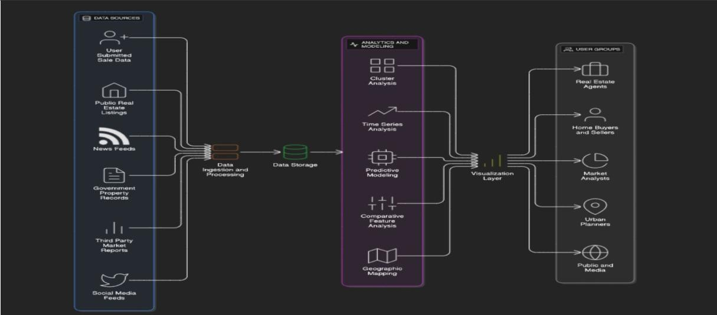

Table-1: Components & Technologies
S.No Component Description Technology
- User Interface Web access to visual dashboards Web UI using Tableau
Public

- Application Logic-1 Data pre-cleaning and
transformation

- Application Logic-2 Dashboard logic, filters, calculated
fields
Python (Pandas, NumPy)

Tableau Desktop

- Application Logic-3 Interactive story design Tableau Story Builder
- Database Structured data in tabular format CSV file (Transformed
Housing Data)

S.No Component Description Technology

- Cloud Database Optional sync with Google Sheets or Google Sheets / Tableau
Tableau Online Cloud

7 File Storage | Storing housing datasets | Google Drive / Local File System
8 External API-1 | (Not used in current scope) | N/A
9 External API-2 | (Not used in current scope) | N/A

- Machine Learning Model
Future enhancement for price prediction
Python Regression Model (optional)

- Infrastructure Deployment & Hosting Local System, Tableau
Public (Cloud)

Table-2: Application Characteristics:
S.No Characteristics Description Technology

- Open-Source
Python for preprocessing, Tableau Public for Python (Pandas, NumPy),

Frameworks
- Security Implementations
visualization
Dashboard access restricted via Tableau share settings and Google logins
Tableau Public
Tableau account authentication

- Scalable Architecture Scalable to new visualizations and datasets Tableau Dashboards, CSV
Expansion
- Availability Available 24/7 via Tableau Public Hosted on Tableau Public /
Online

- Performance Lightweight visuals, quick filter response,
cache-enabled Tableau dashboards
Tableau's optimization engine

`˙ˆ•˙ References
  - https://c4model.com/
  - https://developer.ibm.com/patterns/ai-powered-backend-system-for-order-processing- during-pandemics/
  - https://aws.amazon.com/architecture
  - https://public.tableau.com
  - https://medium.com/the-internal-startup/how-to-draw-useful-technical-architecture- diagrams-2d20c9fda90d

